Get multiple users exiting assignment service: GRAC_IDM_USER_ASIGNMT_SERVICES

Restriction: Function module GRAC_IDM_USER_ASIGNMT_SERVICES can give details for only one user. To overcome this restriction for multiple users, I have created custom function module. ZGRAC_IDM_USR_ASIGNMT_SERVICES

Importing parameter

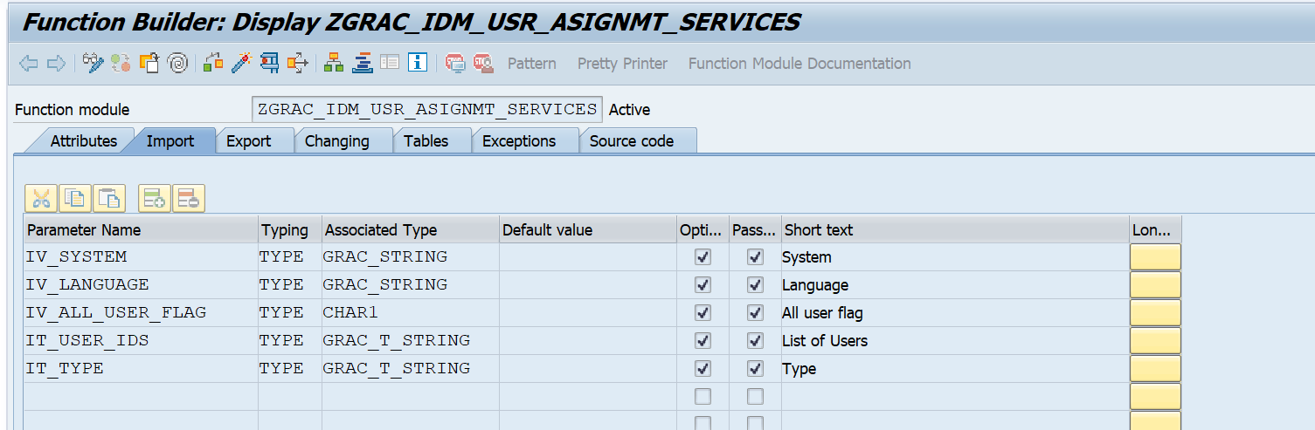

Exporting parameter

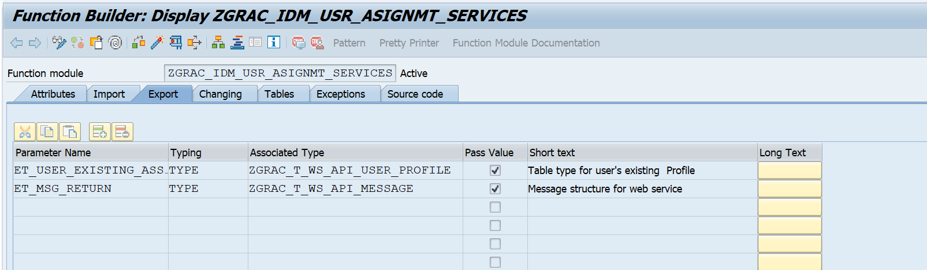

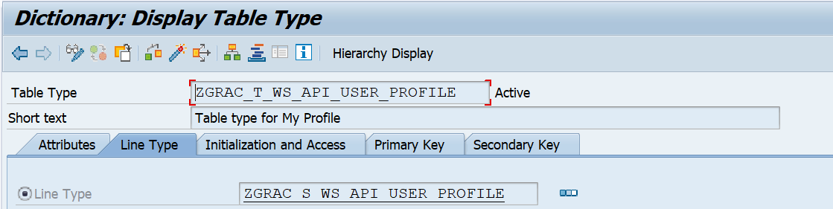

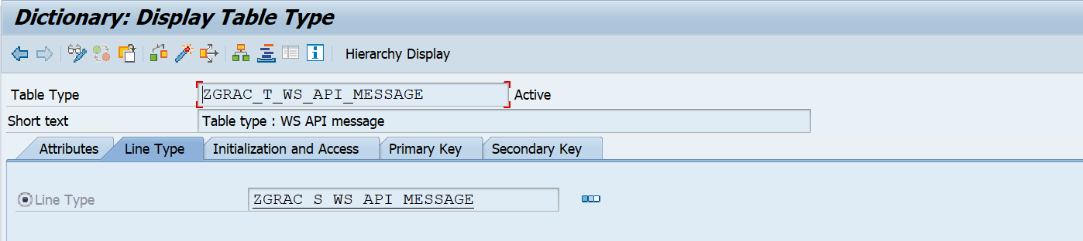

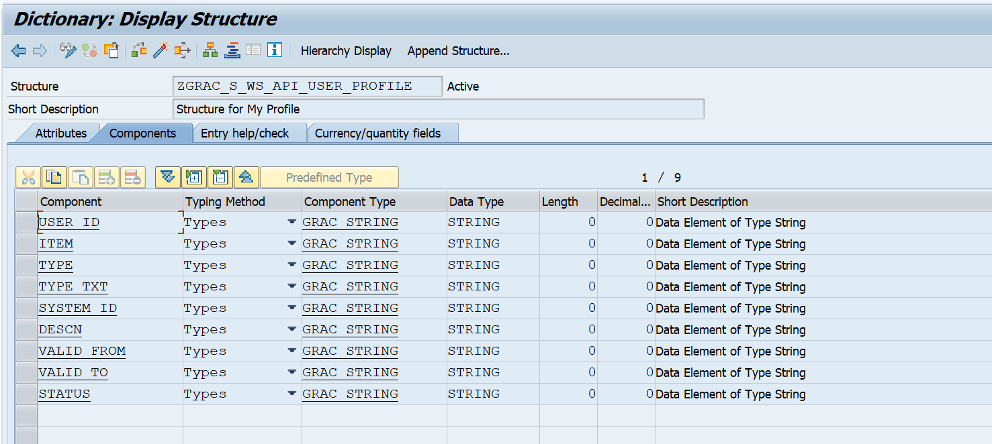

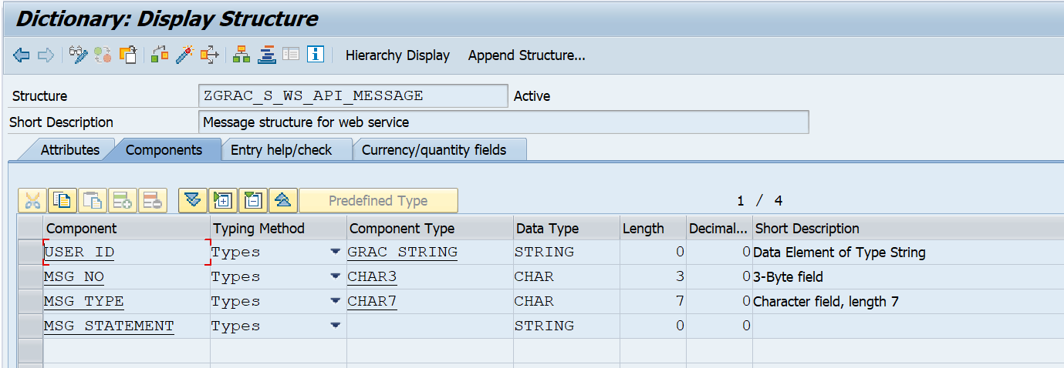

Code is below attached document.



After creation of function module created, same function module is used to create web service so that external system get required details of User.

Below is attached document for web service creation.

